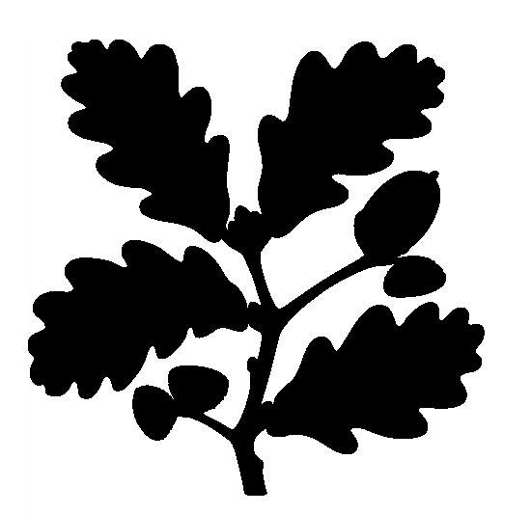
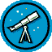

PRESENTATION
(Upstairs at the café)

7.30pm Introduction to the Night Sky by Chris Starr (Wells and Mendip Astronomers)
A brief introduction to the wonders of the night sky

8.15pm Your First Telescope by Adrian Dening (Charterhouse Observatory)
Tips on how to make a journey into space without spending the equivalent of a manned NASA mission!

9.00pm History of NASA Manned Space Flight by John Parrott (N. Devon Astronomers)
Does exactly what it says on the tin!! Presented by John who himself has had experience of the NASA training programme!

DISPLAYS
(In the house at Squire’s Gate)

- Astrophotography with Jo and Pete from Bleadon, Somerset
- Wells and Mendip Astronomers
- Space Odyssey Planetariums
- Campaign for Dark Skies
- Sowy Astronomers
- Charterhouse Observatory and Astronomy Courses

GAZE AT THE NIGHT SKY… weather permitting!
(On the prom)

- Telescopes of all shapes and sizes will be manned by local astronomers and available for public viewing and instruction at the rear of the main cafe building
- Please be careful in this area as most telescopes are tripod mounted and it will be DARK
- Torches (other than red astronomy torches) should be kept to a minimum in order to aid night vision



Brean Down

