Comet Johnson

The following star charts are in reverse order.

4th March 10:30pm

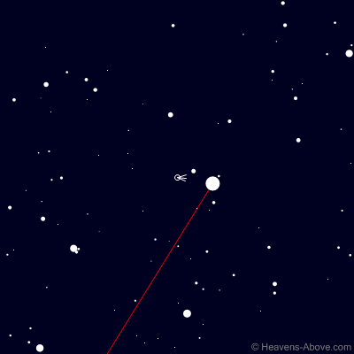

2nd March 10:30pm

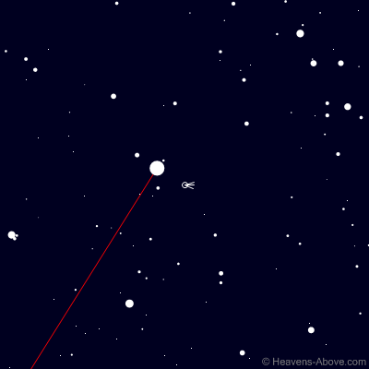

Hercules constellation -2nd March

