The following star maps position Vesta for the following dates in Gemini.

1st March

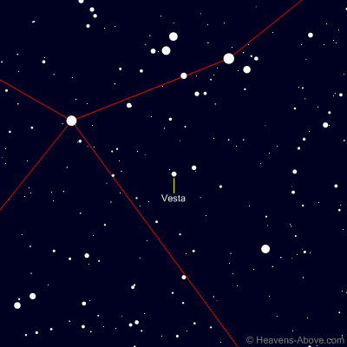

11th March

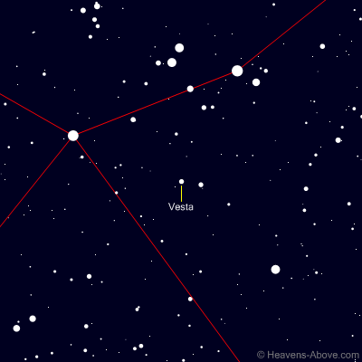

21st March

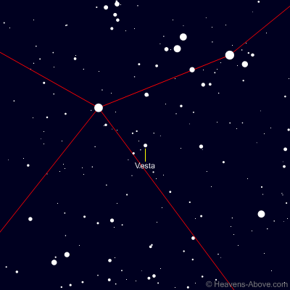

31st March. Top bright left star is Pollux

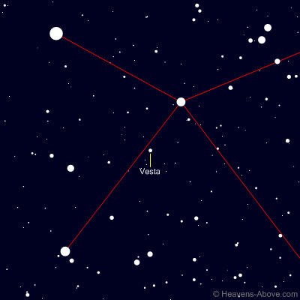

From Adrian Zielonka