I have the following items for sale. I am asking what I believe to be a fair price but am open to reasonable offers.
- Skywatcher AZ-EQ6GT PRO SYNSCAN MOUNT AND TRIPOD.
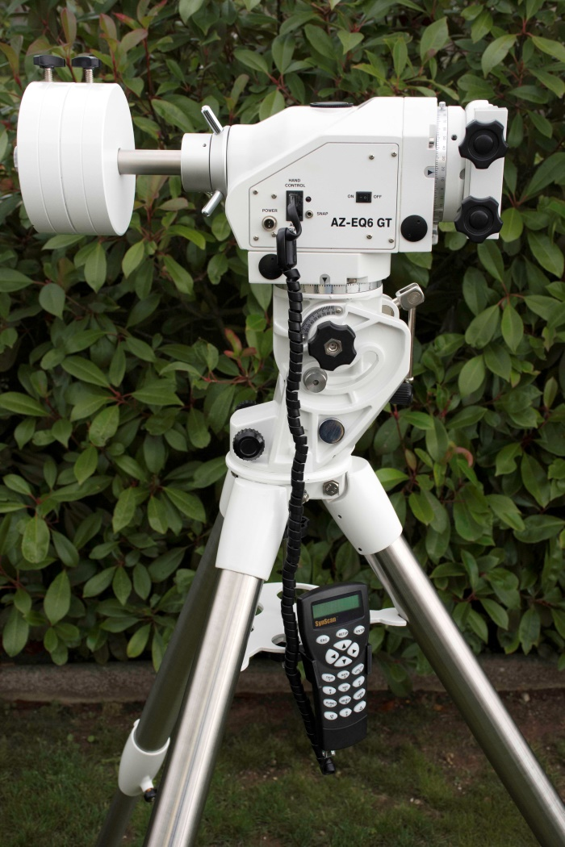
This mount has only been used a maximum of 10 times and is in perfect condition and working order. It comes with all the accessories and, in addition, a purpose made transit case.
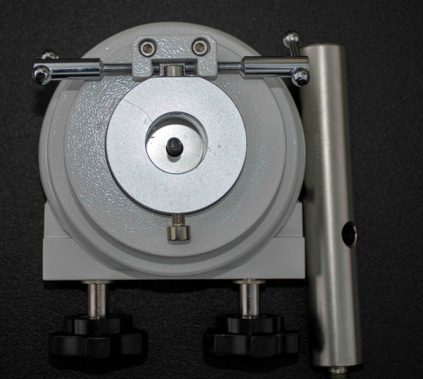
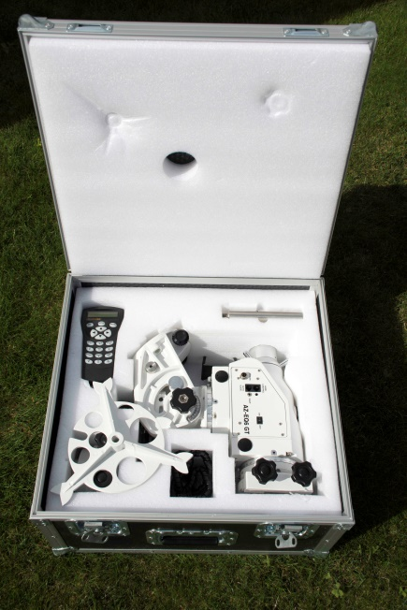
Additional puck and counterbalance extension bar
£1000

- Skywatcher Quattro 250st (10 inch) f/4 Imaging Newtonian.
This item is in very good condition. It is fully flocked, has a cooling fan fitted (courtesy of The Astronomy Shed), a Hitecastro DC Focus Controller and an Orion 9x50 Right-angle finder scope.

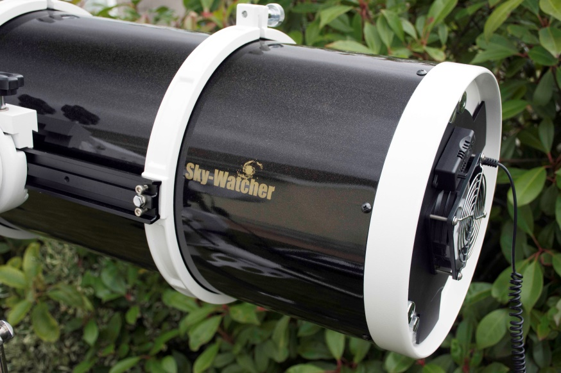
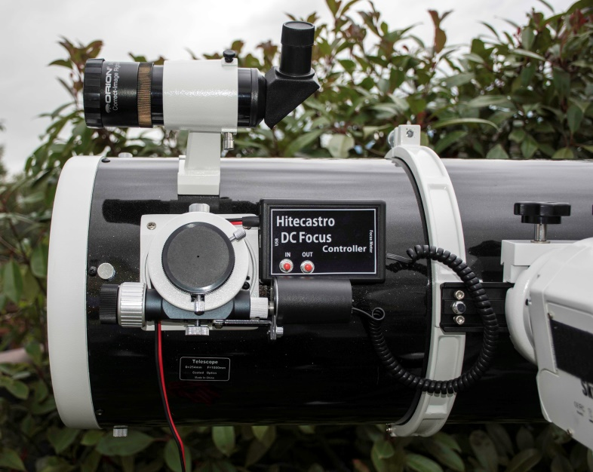

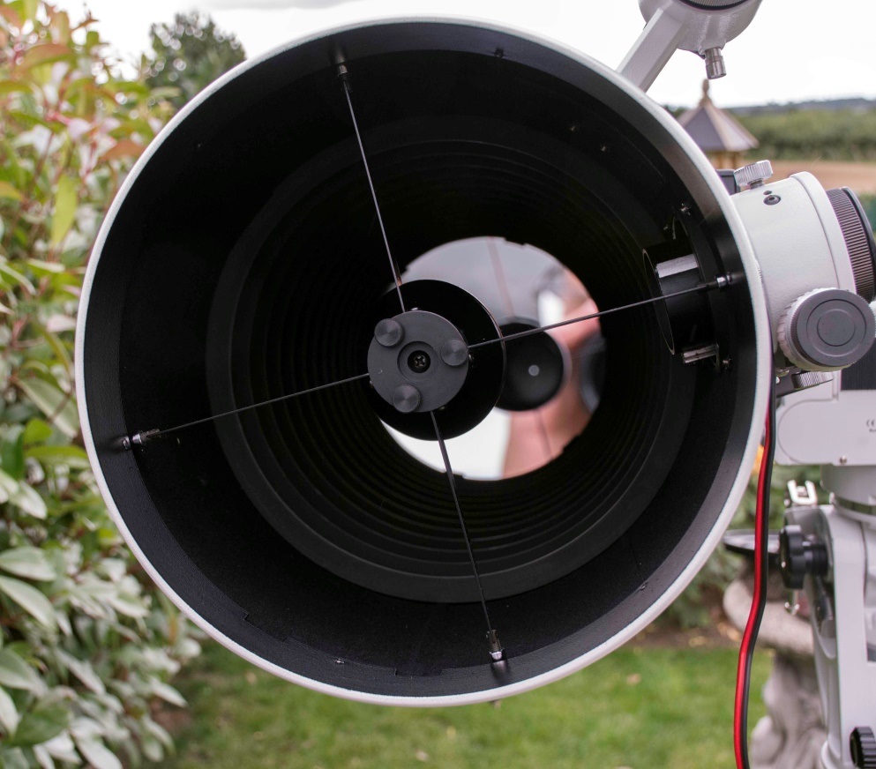

£300

- Meade 5000 Series 127mm ED Apochromat f7.5 Triplet Refractor.
This refractor is recognised as one of the best mid-priced units ever to enter the market. You can see great reviews for it online. I have had it for 6 years. It has a Moonlight dual speed focuser and Bhatinov Mask for the discerning astro-photographer.

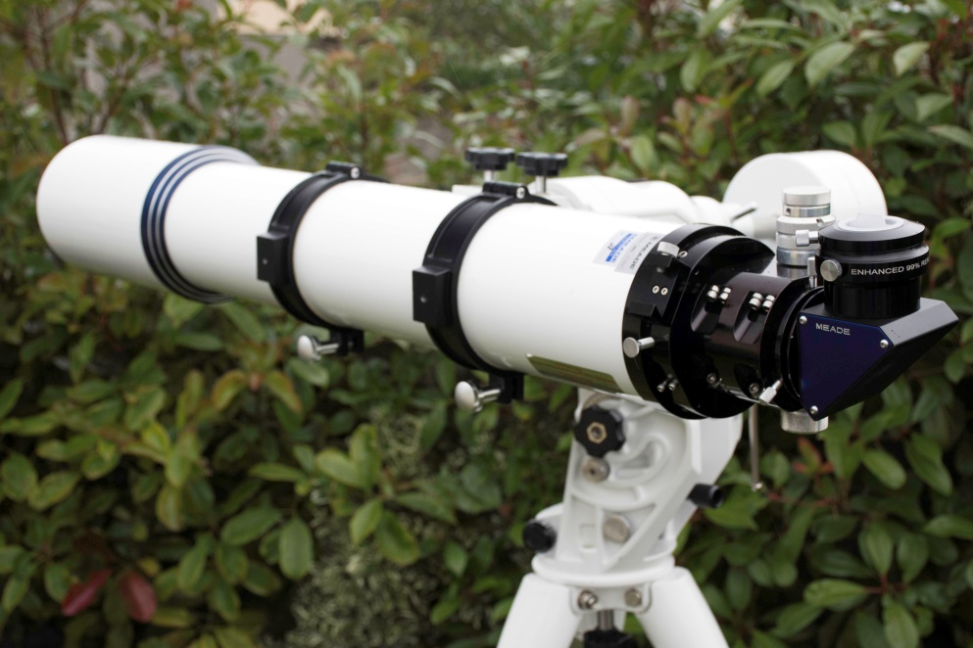

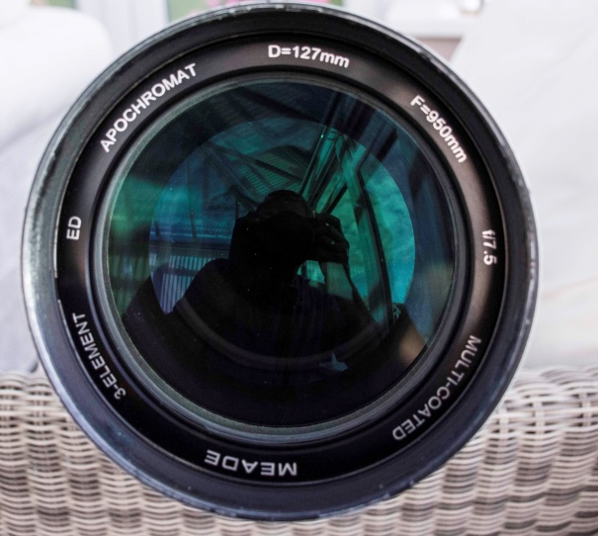
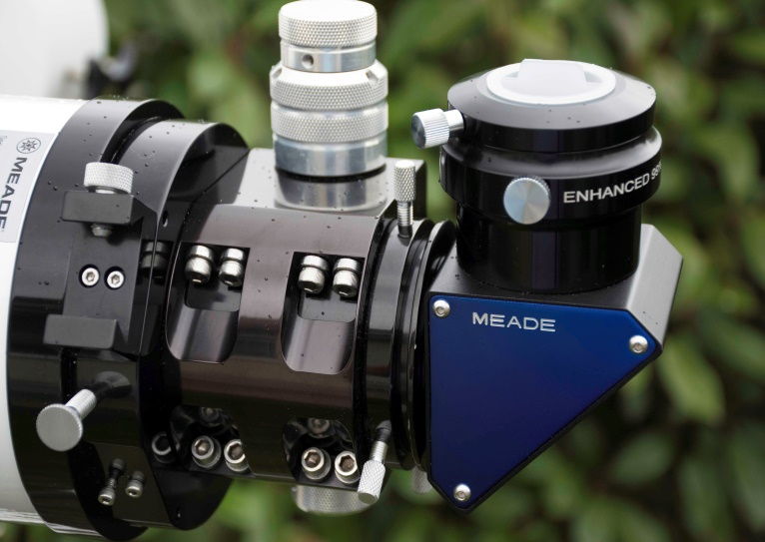
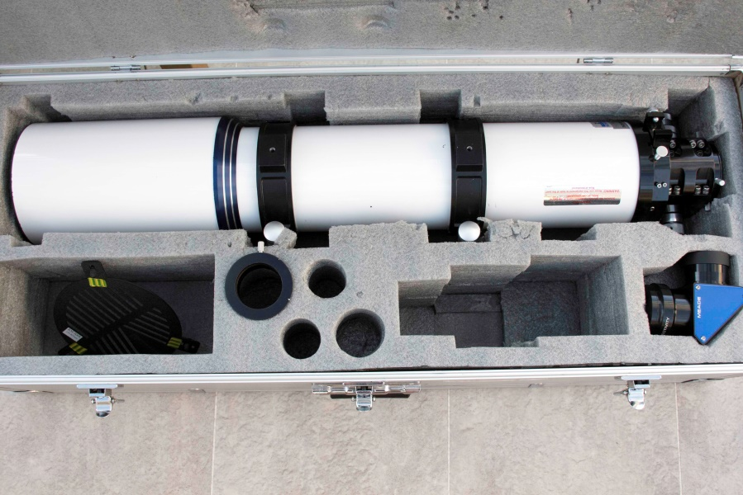

£600

- The following items which are all in either very good or excellent condition are priced as indicated:

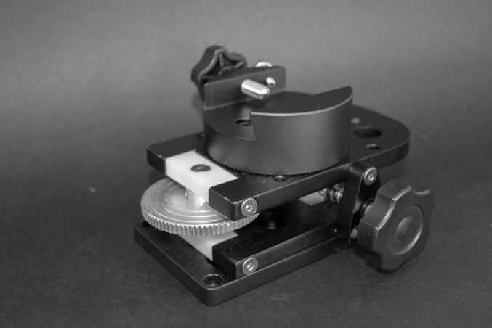
- Skywatcher Guidescope Mount.

£75

- Baader Planetarium Witty Tangent Assembly (Piggyback Camera Mount) with additional base.
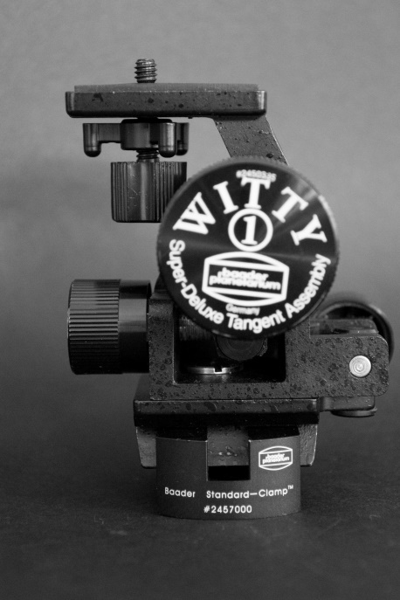

£35

- ADM Vixen Side by side mount

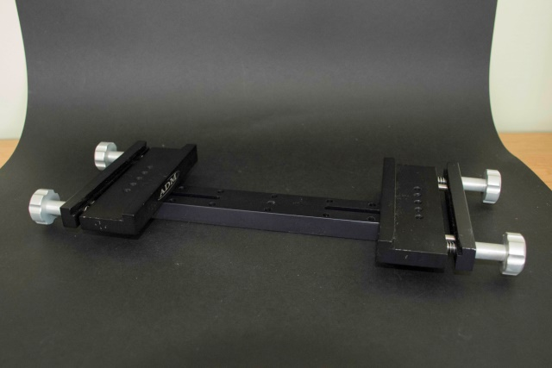

£60

- Orion CT 80mm Refractor (autoguider scope).
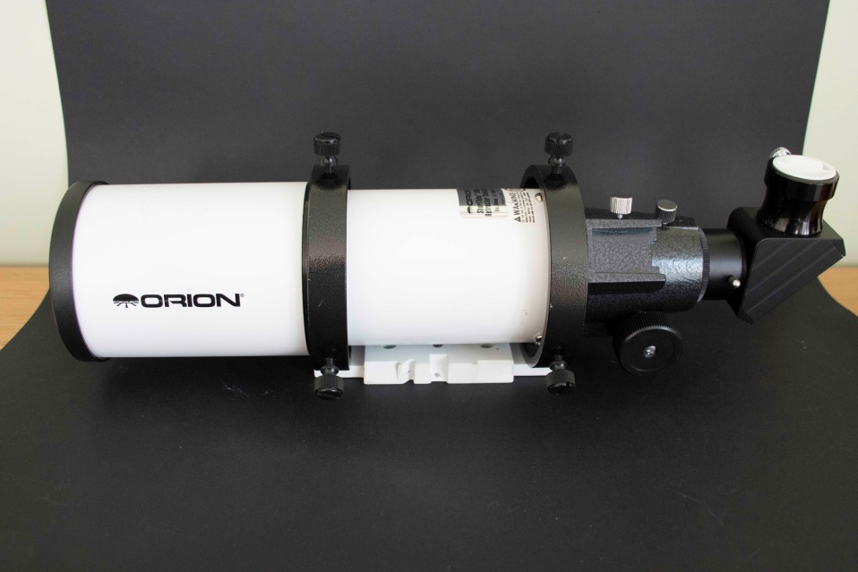

£35

- Hotech Laser Collimator.
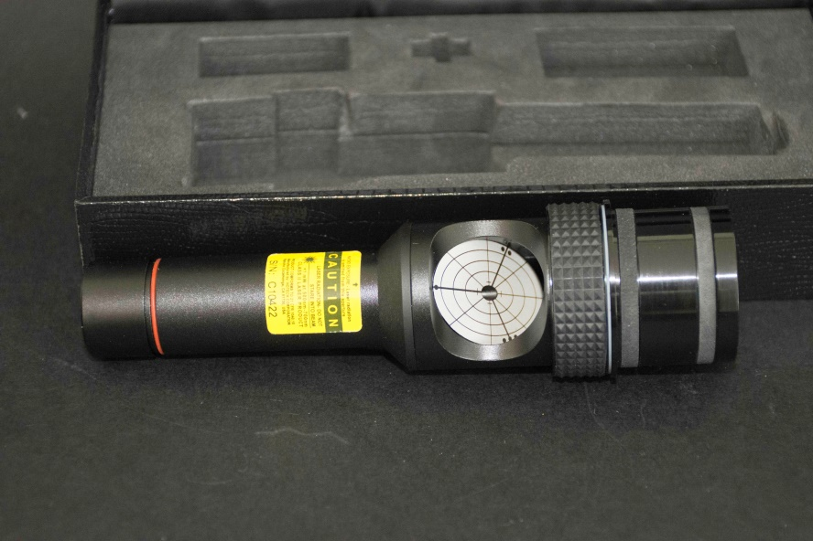

£45

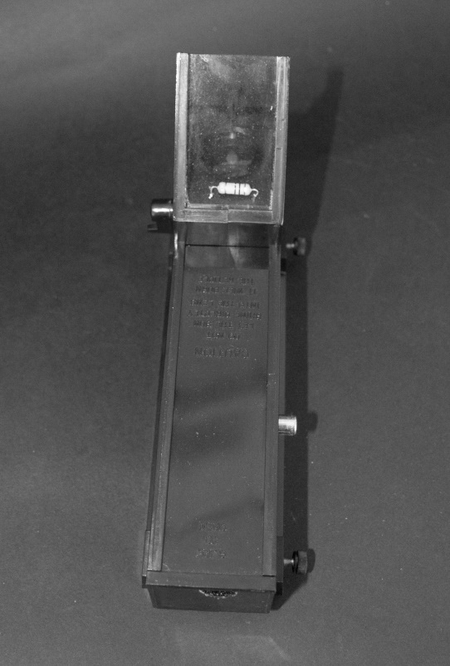
- Telrad Finder (modified with internal dew heater connects to dew controller) complete with base.

£20

- Telrad Finder complete with base and extender base.
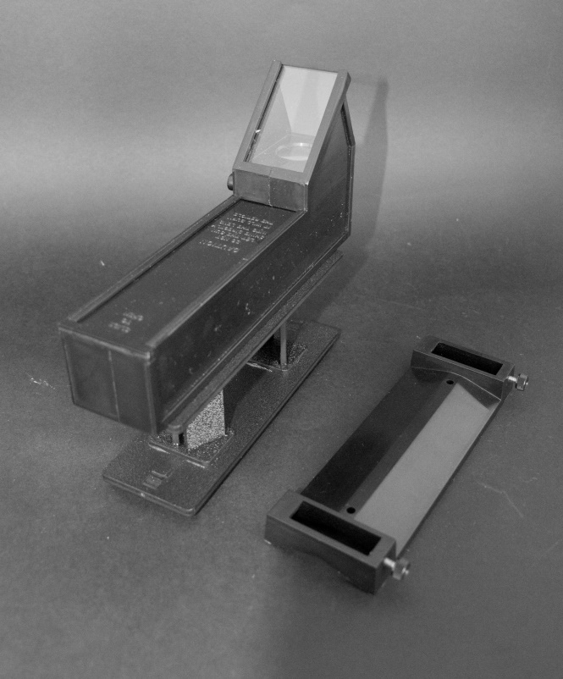

£25

- GSO Super Plossl eyepieces (6mm, 15mm &25mm).
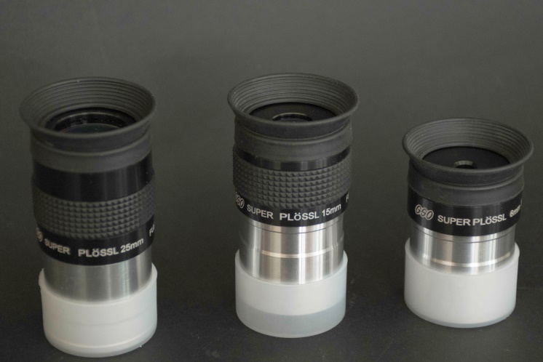

£15 each or all 3 for £40

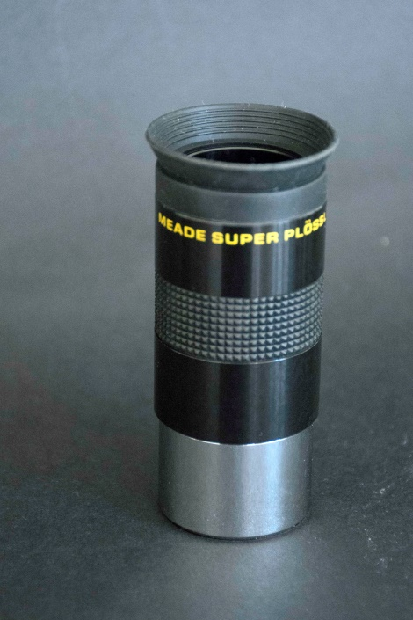
- Meade Super Plossle eyepiece

£15

- Unspecified Illumated Reticulated eyepiece (good for aligning scope to finder).
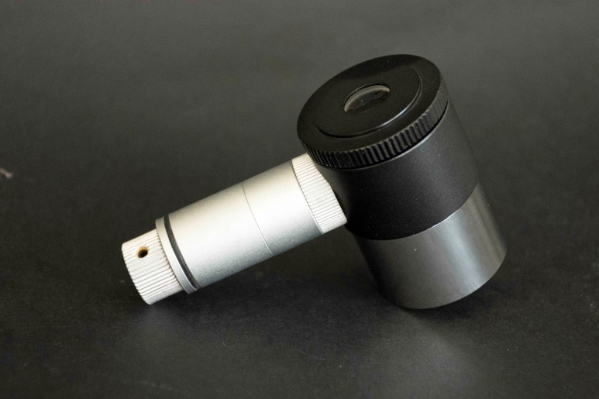

£15

- Meade 5000 Series 40mm Super Wide Angle eyepiece.
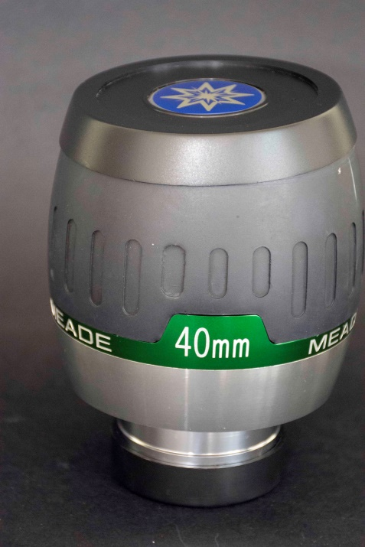

£25

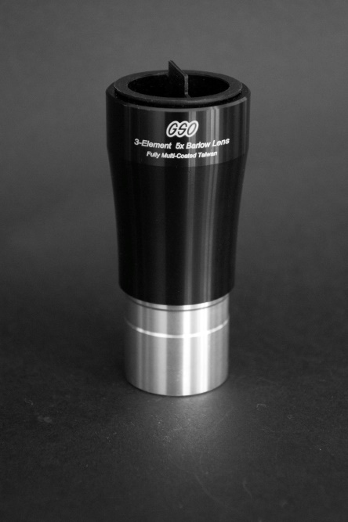
- GSO 5 X Barlow Lens

£25

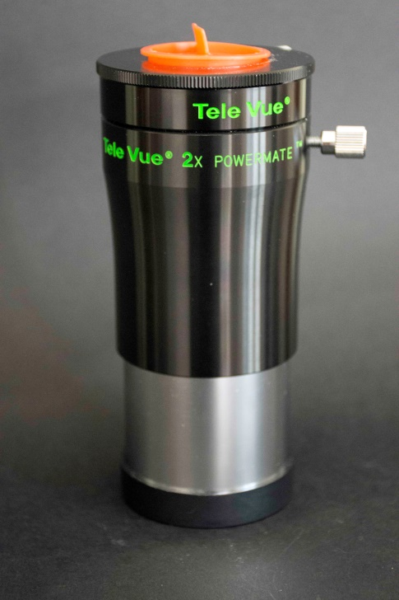
- Televue 2 X 2inch Powermate (top quality optic).

£230

- Set of Altair Astro self centering rings (35mm and 50mm) plus 2inch to 1.25 self centering eyepiece holder.
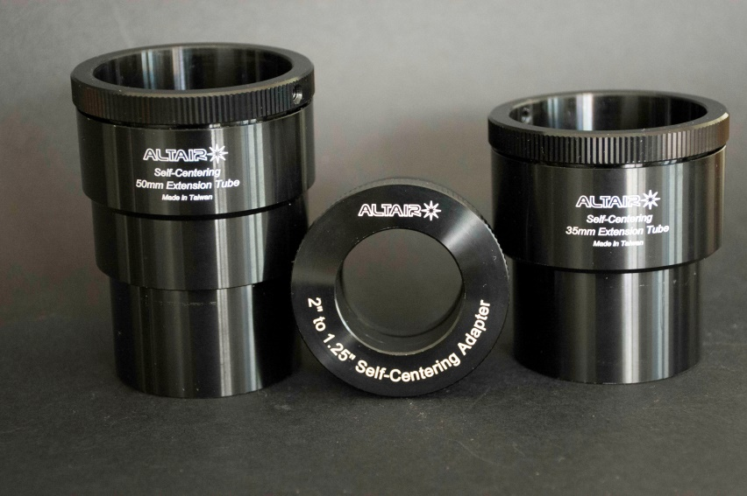

£20

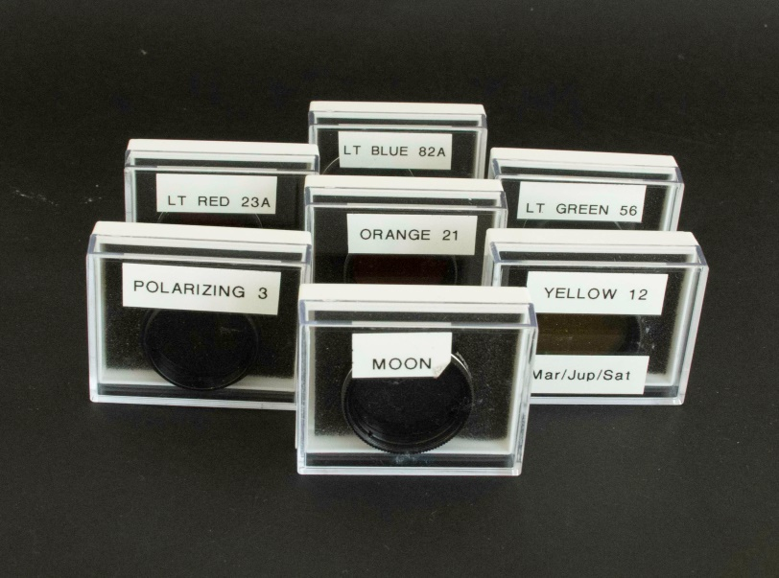
- Set of 7 coloured filters

£15

- Baader Planetarium 1.25inch O III Visual Filter 8nm.
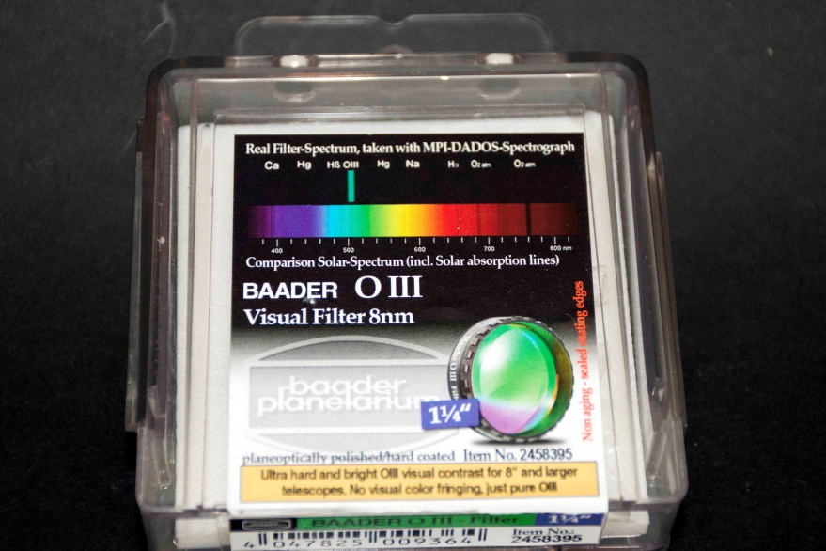

£45

- Baader Planetarium 2 inch O III Visual Filter 8nm.
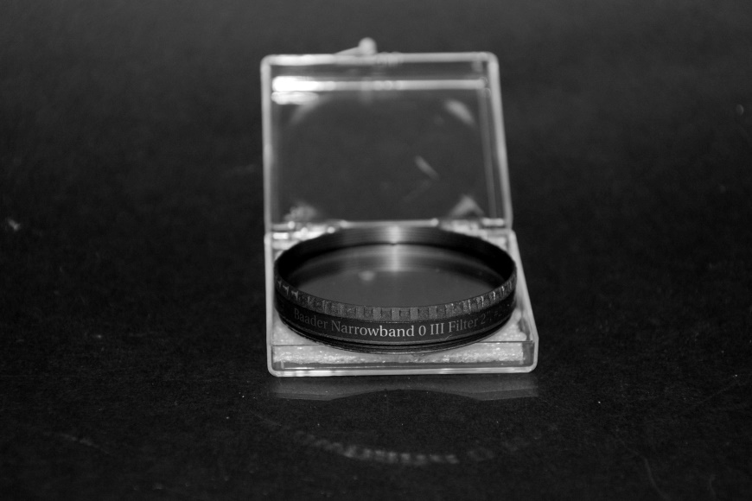

£80

- Baader Planetarium 1.25 inch L Booster Visual and Photographic UHC-S Nebular Filter
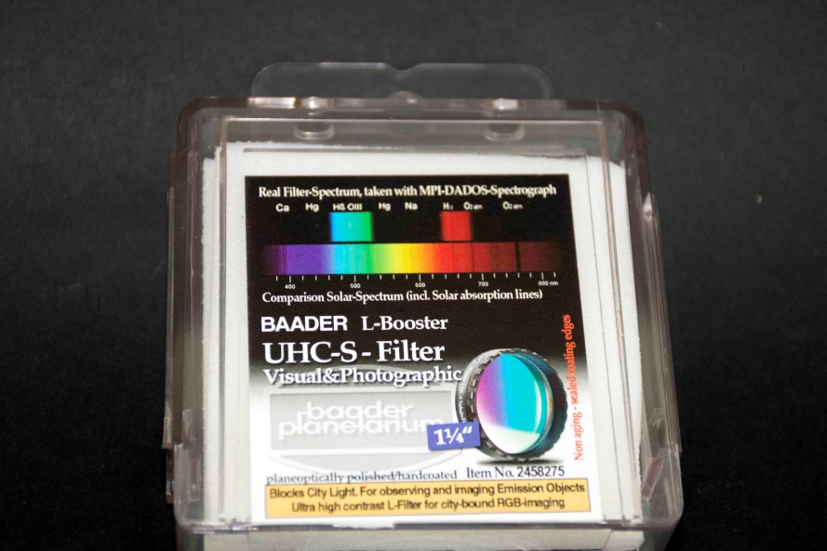

£45

- Baader Planetarium 2 inch L Booster Visual and Photographic UHC-S Nebular Filter.
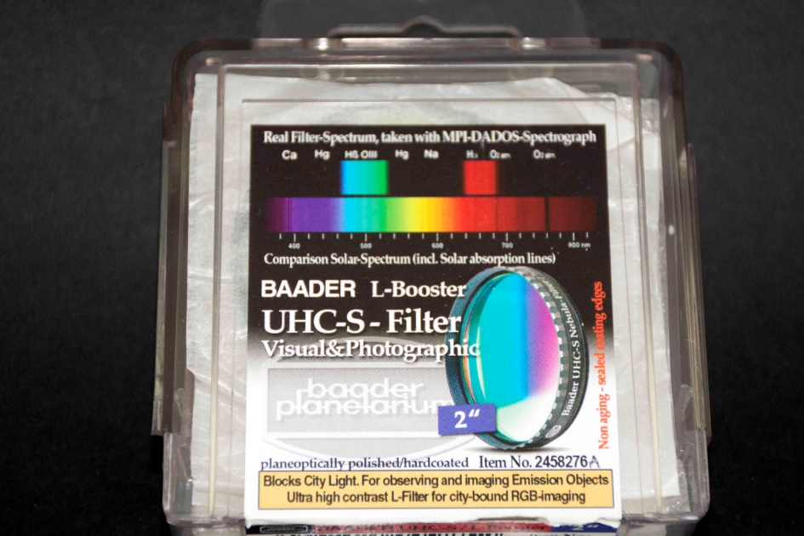

£65

- Baader Planetarium Multi Purpose Coma Corrector MPCC Mark III suitable for T2 and M48
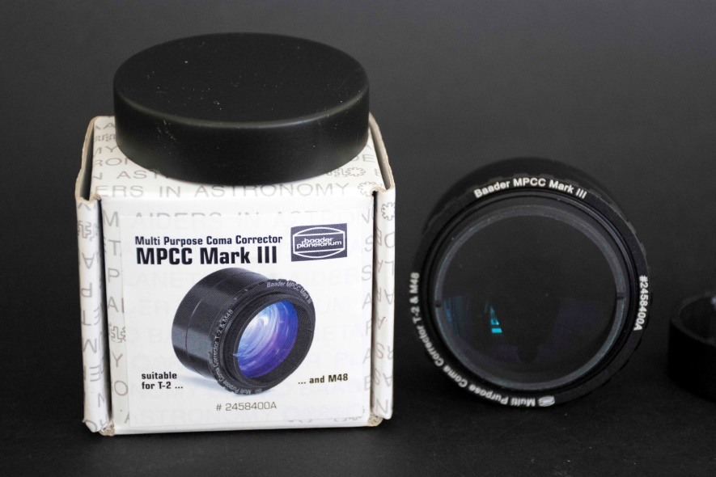

£125

- QHY 5-II Colour CCD Planetary/|Guiding Camera. This comes in a box with adaptors and leads and is complete.
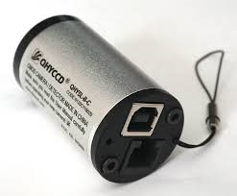

£60

